Characters in the play

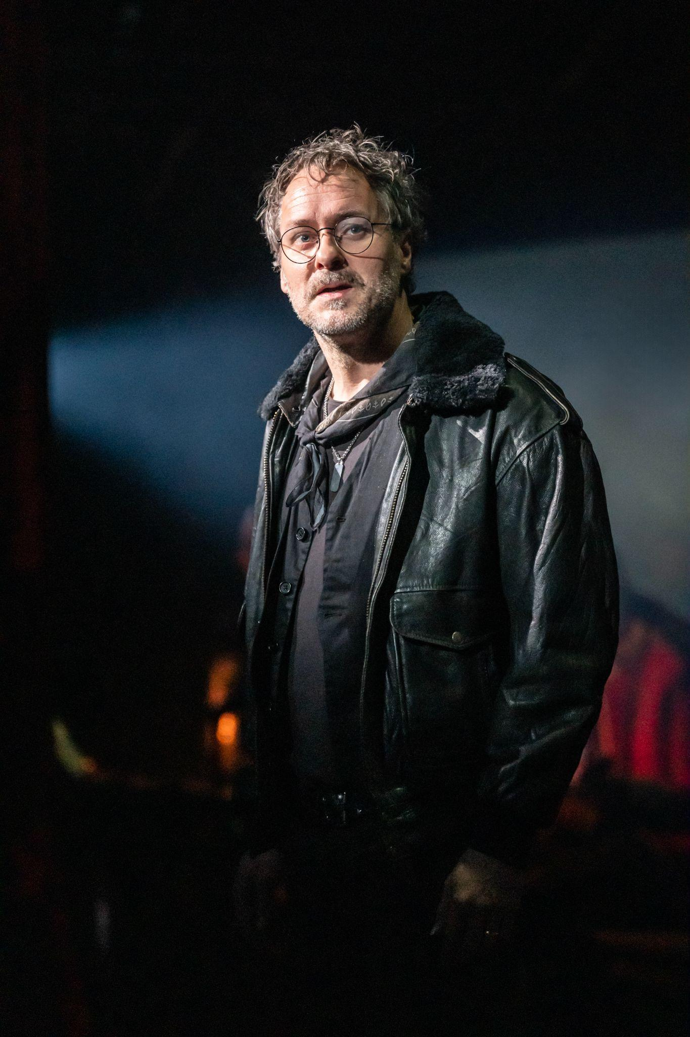

This is Pierre

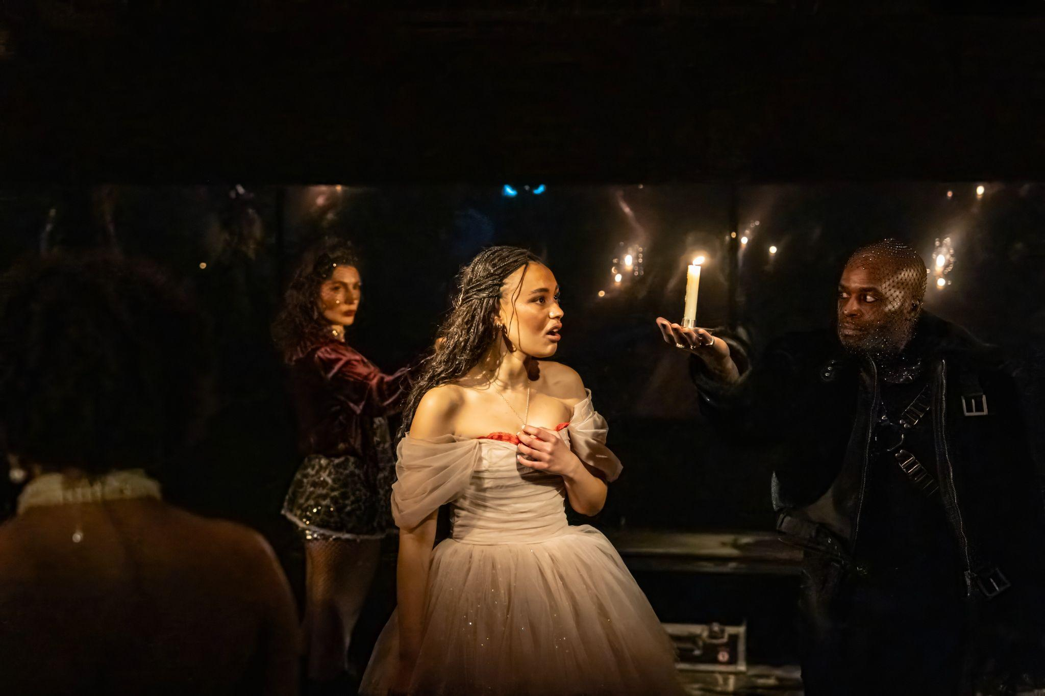

This is Countess Natasha Rostova, She also plays a member of the Chorus.



This is Fedya Dolokhov, He also plays a member of the Chorus.

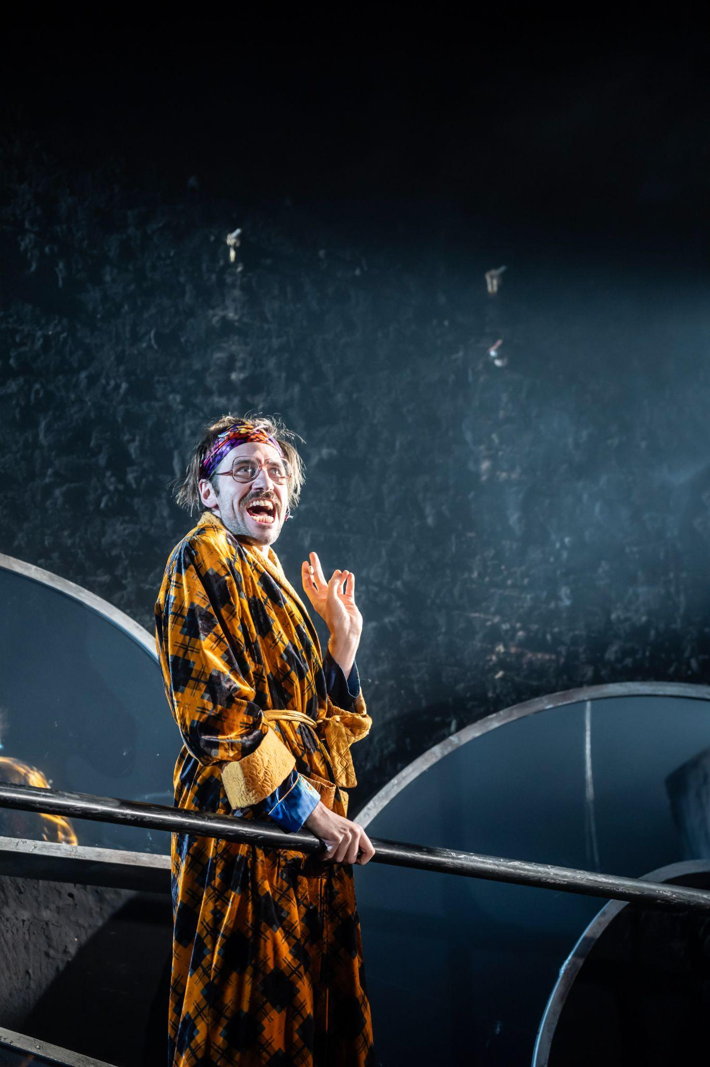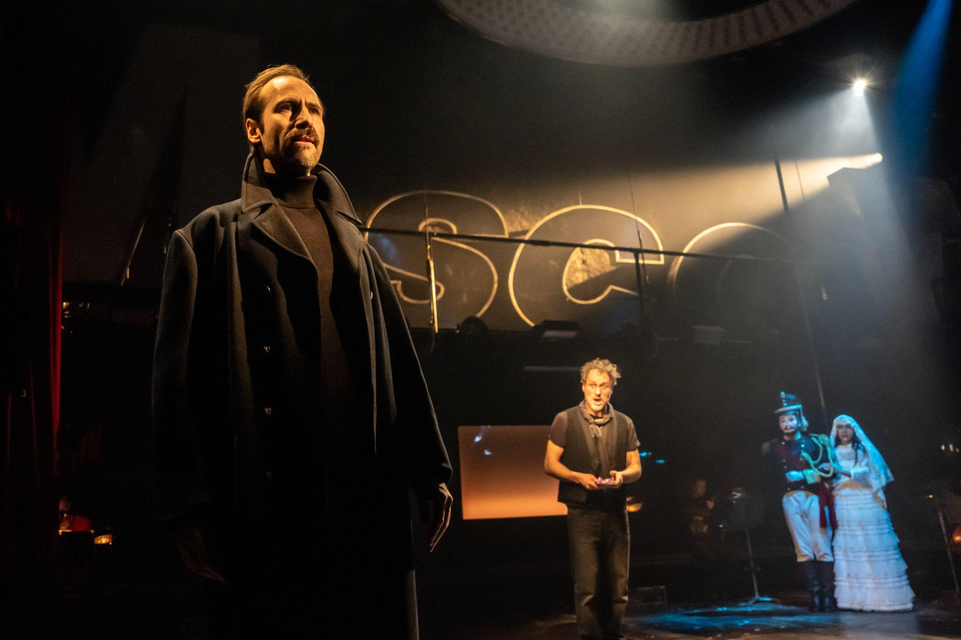

This is Prince Bolkonsky / Andrey, He also plays a member of the Chorus.

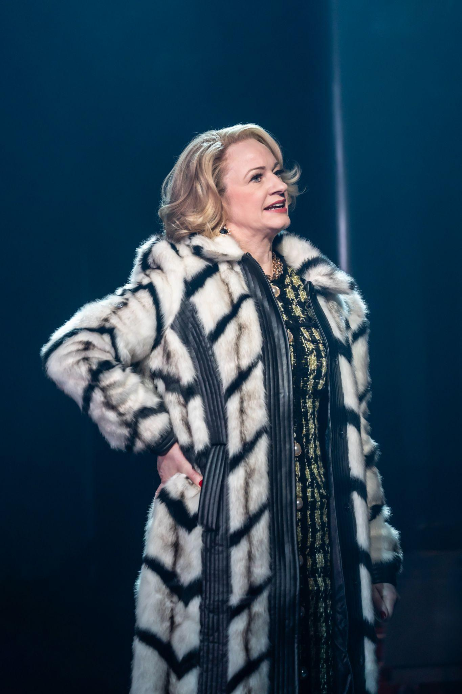

This is Marya Dimitritevna, She also plays a member of the Chorus.

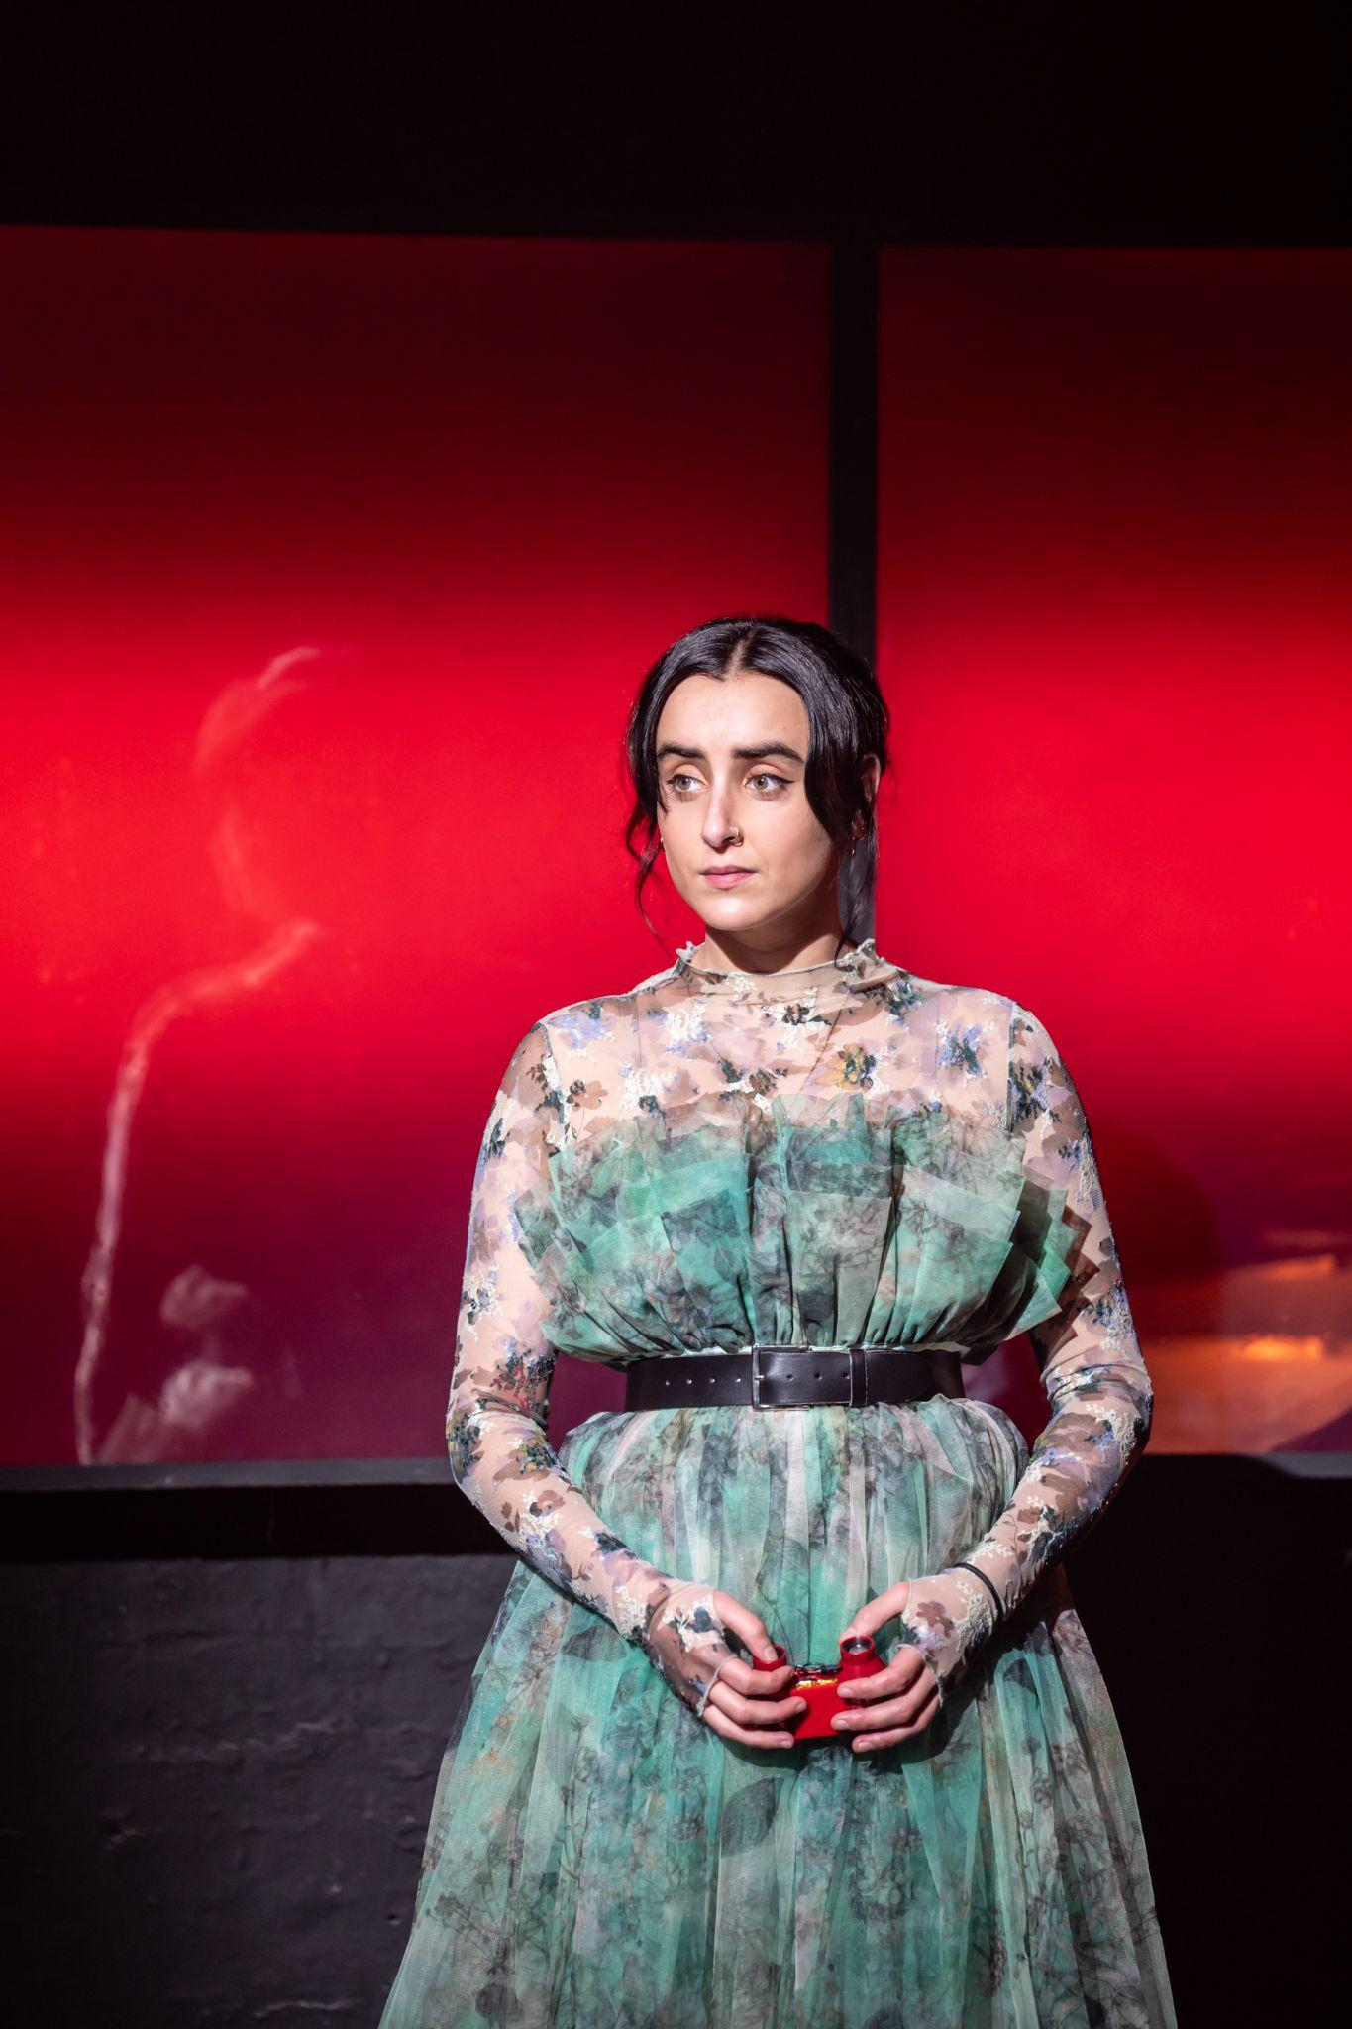

This is Sonya Rostova, She also plays a member of the Chorus.

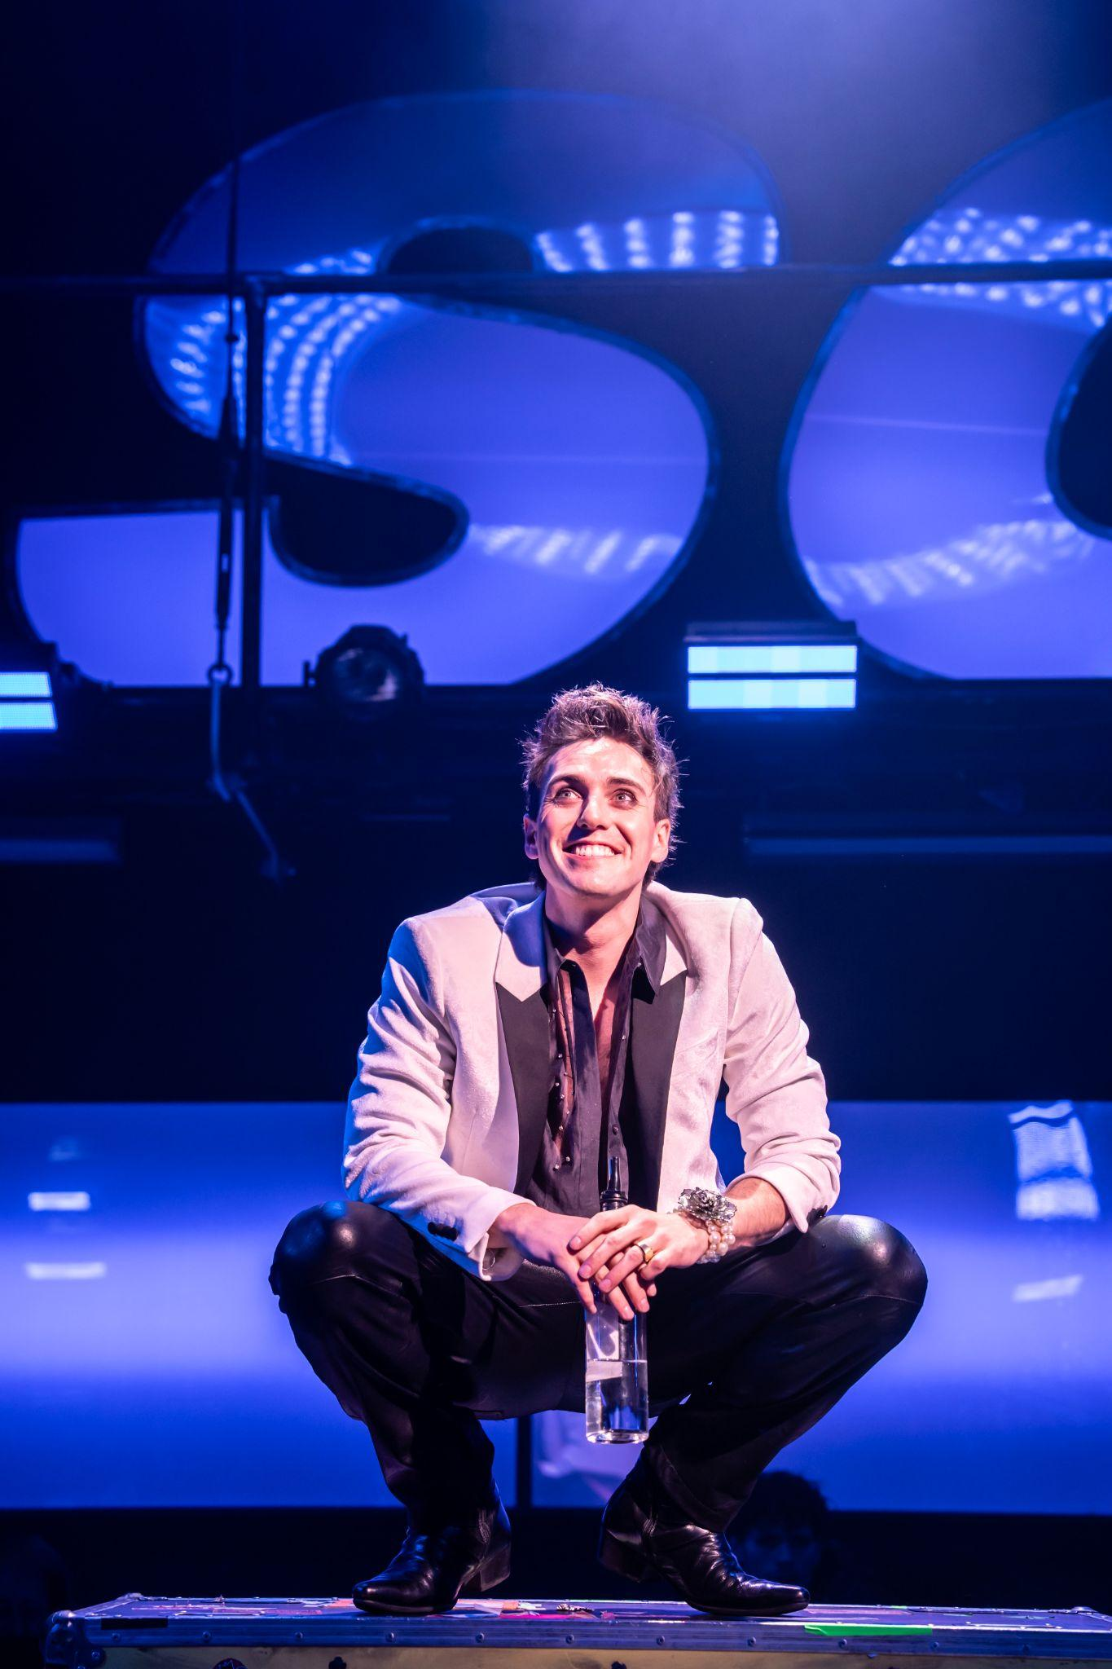

This is Anatole, He also plays a member of the Chorus.



This is Balaga, He also plays a member of the Chorus.

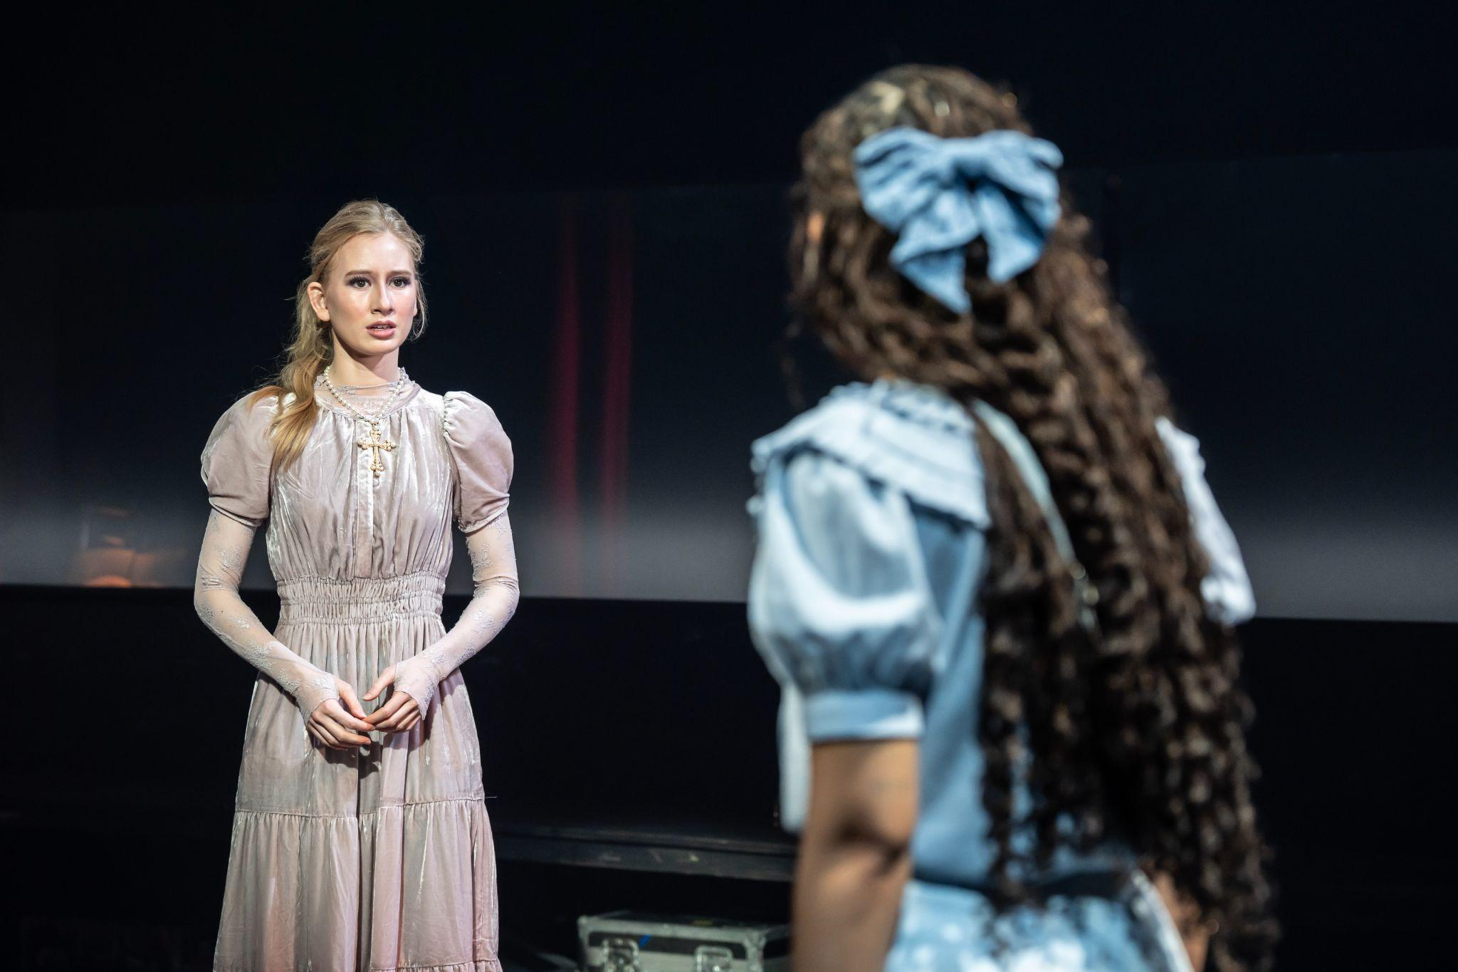

This is Mary/Cover Natasha. She also plays a member of the Chorus.

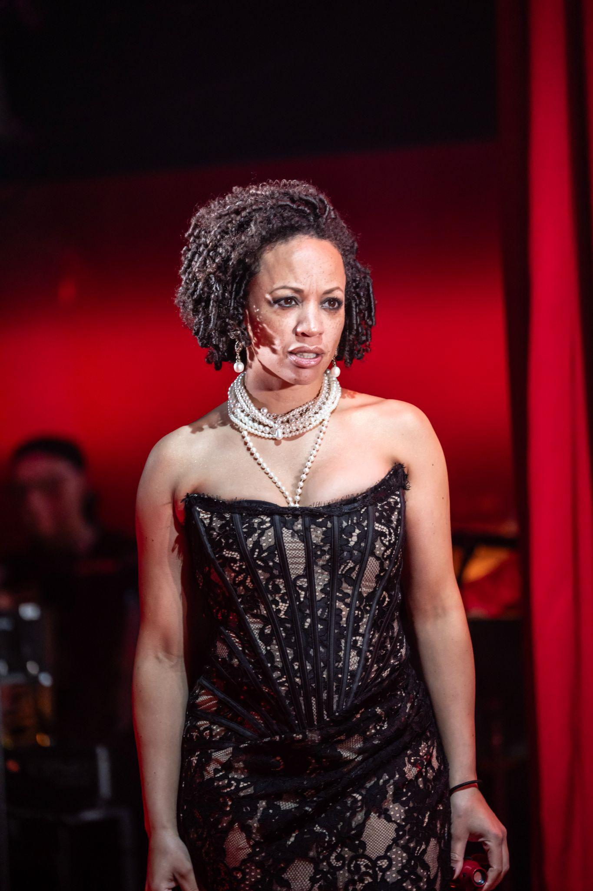

This is Hélène Kuragina Bezukhova, She also plays a member of the Chorus.



This is a member of the Ensemble/Cover Prince Bolkonsky

Andrey and Balaga. He also plays a member of the Chorus.

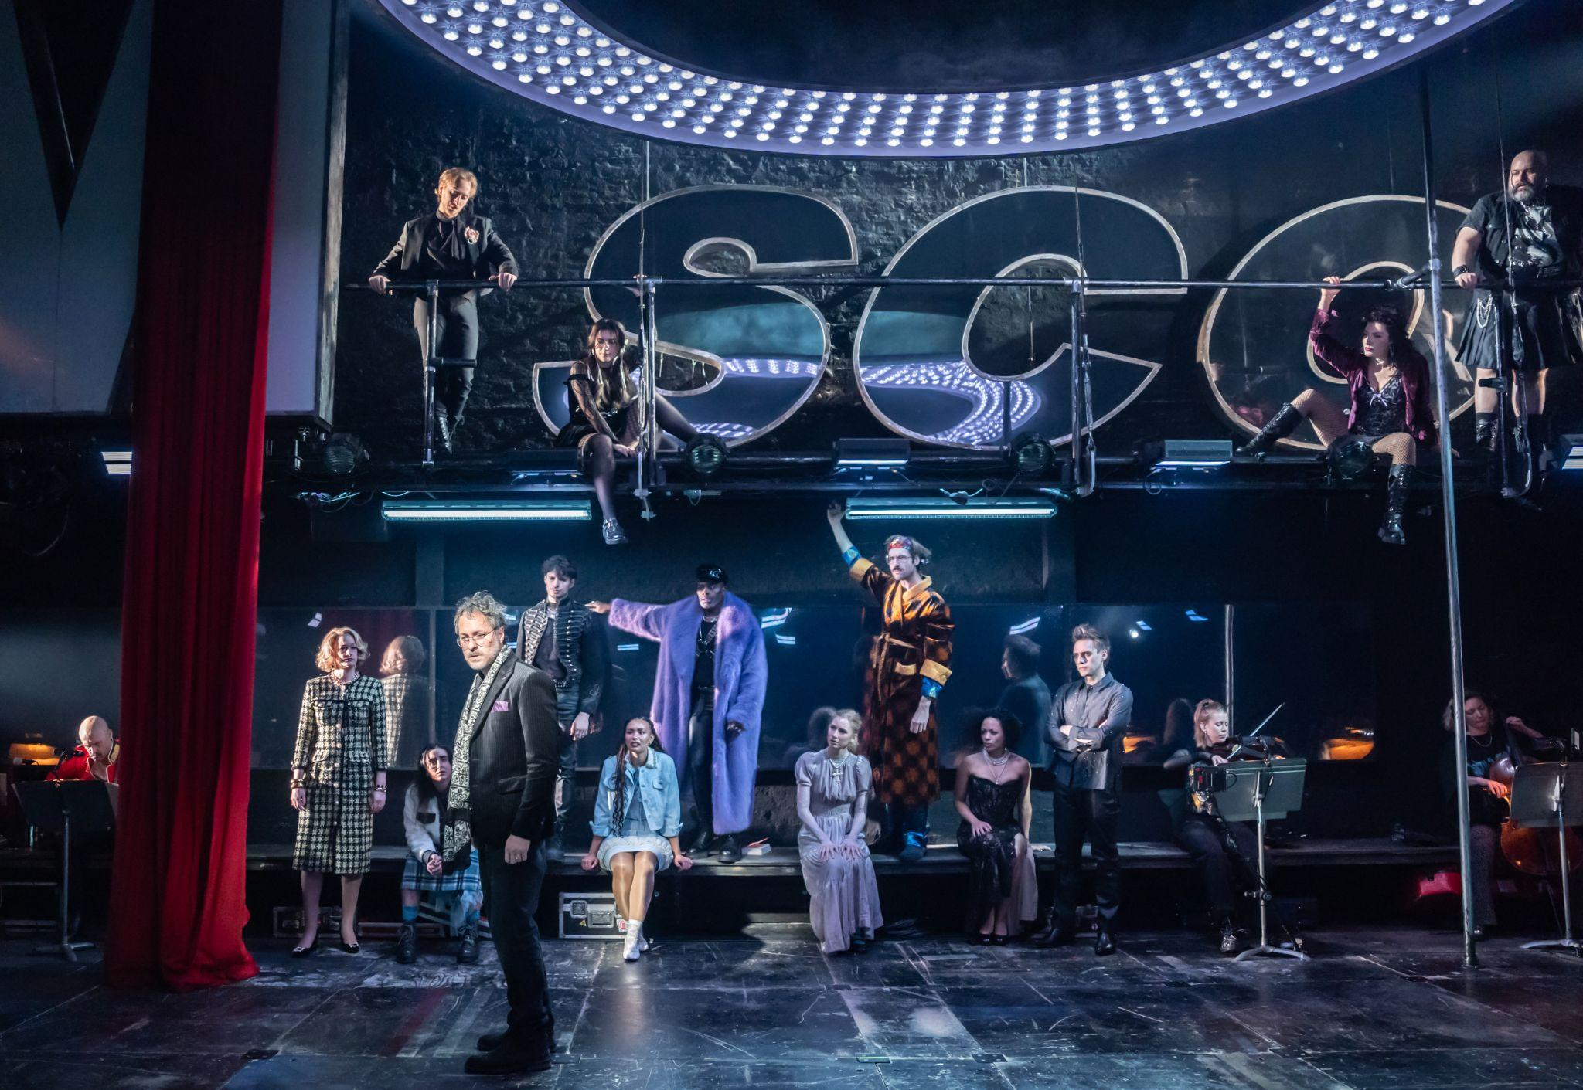

This is a member of the Ensemble/Cover Marya and Hélène.

She also plays a member of the Chorus.



This is a member of the Ensemble. He also plays a member of the Chorus.



This is a member of the Ensemble. She also plays a member of the Chorus.

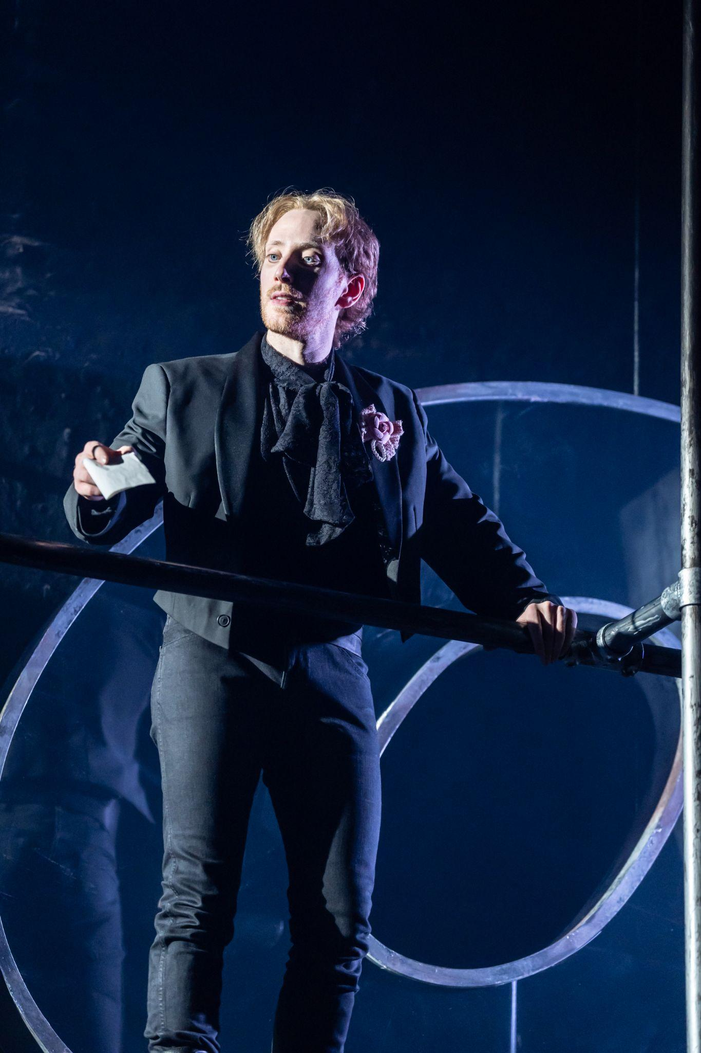

This is a member of the Ensemble/Cover Pierre, Anatole and Dolokhov. He also plays a member of the Chorus.

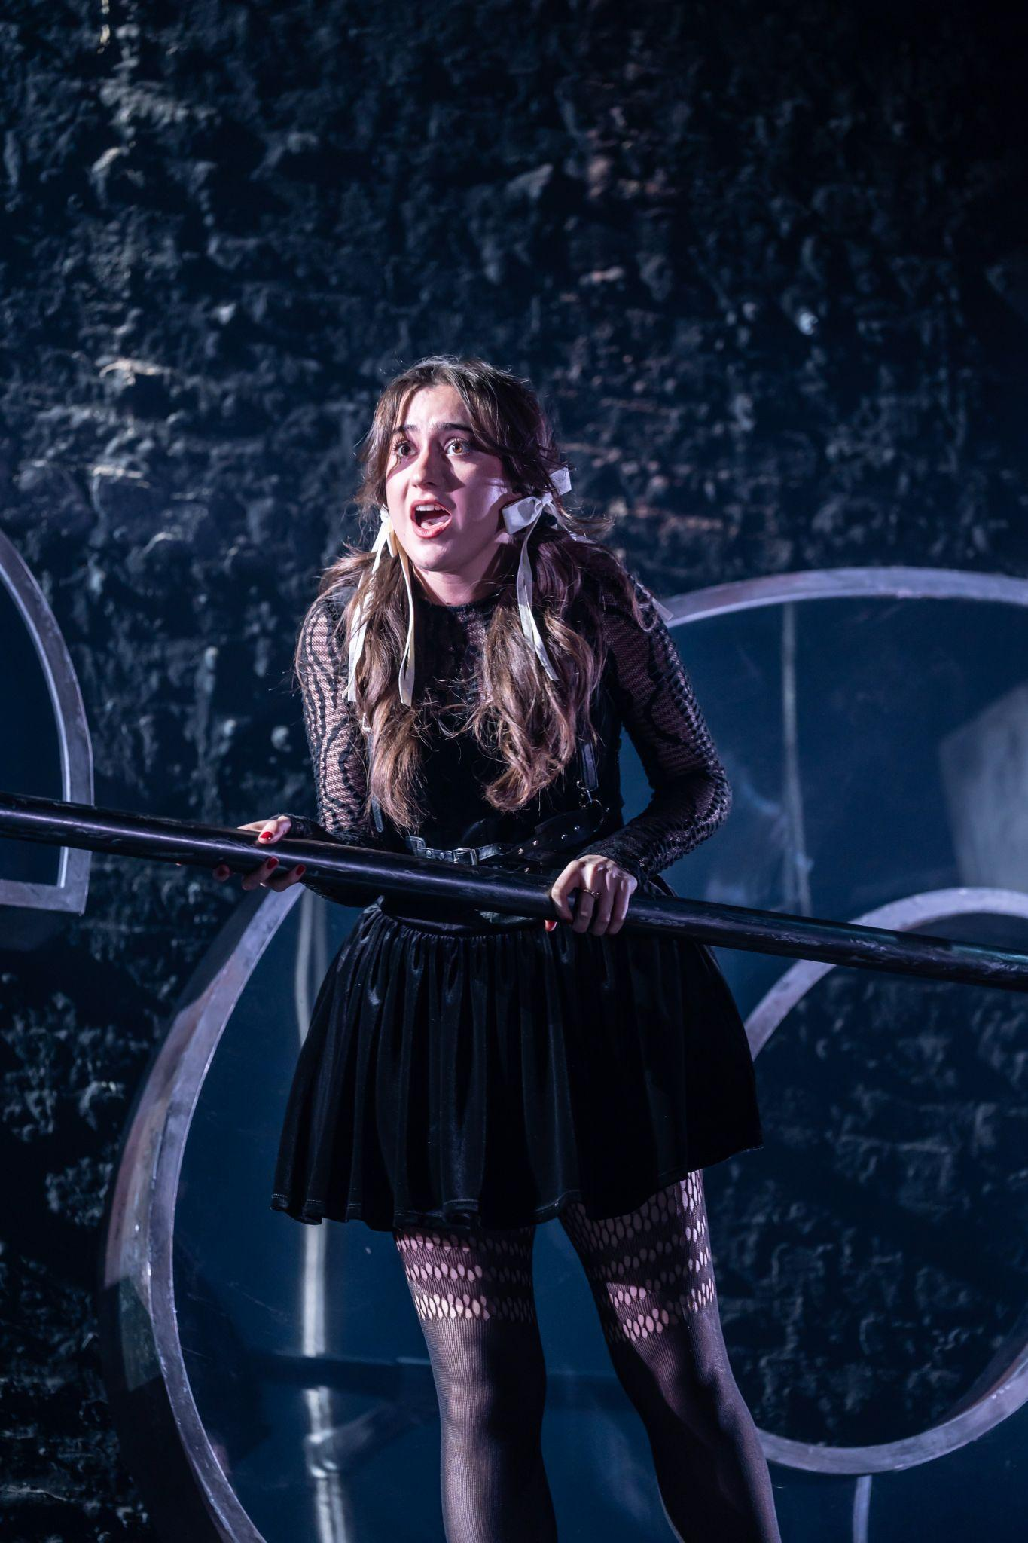

This is a member of the Ensemble/Cover Natasha, Sonya and Mary. She also plays a member of the Chorus.

*Often a character will talk about themself in the third person and say what the character is doing in the scene, even though you might not see them do everything they say. The actor is both narrating the character’s story and playing the character in the scene at the same time. This is part of being a member of “the Chorus”*

*Some actors cover other roles within the production. This will mean if an actor cannot attend the performance, their understudy will perform in their place.*

*The actors will move around the auditorium and through the audience as well as on stage.*

The band will be present in the auditorium at all times *and sometimes they look at and interact with the actors.* There are 8 band members.

You may also see the stage management team in the auditorium, they will be present at times to move props and scenery. Both stage management and the band will be in full costume for the duration of the performance.

**PROLOGUE**

# 1. **Prologue**

Synopsis

The accordionist in the band begins to play the song. Pierre tells us “there’s a war going on out there”. Andrey is off fighting in this war, so he “isn’t here”. The other cast members come onstage and remind the audience that they are at an opera, based on a “complicated Russian novel” and that every character has “nine different names”. This is an exaggeration, but it is true that in Russia one person can be referred to using several different names. For example, in this show, the character Natasha is sometimes called Natalie *and sometimes the characters are referred to by their titles such as the Countess.* The characters are introduced one by one, along with a *visual* characteristic which helps define them, *like a sign name in BSL.* Each time a new character is introduced, the cast also recall the names of all the characters they have already introduced, until the following full list is sung:

“Balaga is fun

Bolkonsky is crazy

Mary is plain

Dolokhov is fierce

Helene is a slut

Anatole is hot

Marya is old school

Sonya is good

Natasha is young

Andrey isn’t here”

One character hasn’t yet been properly introduced: Pierre, who started the song. The cast asks “what about Pierre?”.

Advisories

There is the use of the slur ‘slut’ repeatedly throughout the song.

# 2. **Pierre**

Synopsis

Here we are introduced to Pierre, the central protagonist. The opening song has set in motion Pierre’s story. Now he shares his problems, stating “I can’t go on living as I am” and that he “used to be better”. The chorus describes what Pierre is like. He is “merry”, “dear”, “kind”, “smart”, “eccentric”, and “warm-hearted”, but he is also “one of a hundred sad old men”. Pierre describes how he sits at home and reads whilst his friend (Andrey) fights in the war, and that he drinks too much alcohol. He is also in a loveless marriage. The chorus tells us that he is charming, but has no sex. Pierre doesn’t know how he has ended up like this, but shares a desire to change.

Advisories

Sexual references.

References to alcoholism.

References to war and violence.

References to poor mental health.

**PART I**

**Chapter 1**

# 3. **Moscow**

Synopsis

Countess Natasha Rostova and Sonya Rostova, who are cousins, arrive at their godmother Marya Dimitritevna’s house in Moscow. They are visiting whilst Natasha’s fiance, Andrey is at war. Marya welcomes them to Moscow. Natasha is Marya’s favourite goddaughter. They celebrate with a glass of vodka. Natasha misses Andrey, and as she thinks of him two Russian dolls waltz across the space. Lost in a daydream she dances with the male doll as if it is her fiance. Marya and Natasha sit down to chat, about how her visit isn’t all about having fun and buying dresses. Although she is engaged to Andrey, she doesn’t yet have his father, Prince Bolkonsky’, blessing. Marya warns Natasha about the Bolkonskys, how the father doesn’t approve and that she will need to ‘kind’ to the sister; Princess Mary.

Advisories

Confetti is thrown into the air onstage.

Alcohol consumption. It is not real.

Two cast members wear masks, which fully cover their faces.

Rude gestures.

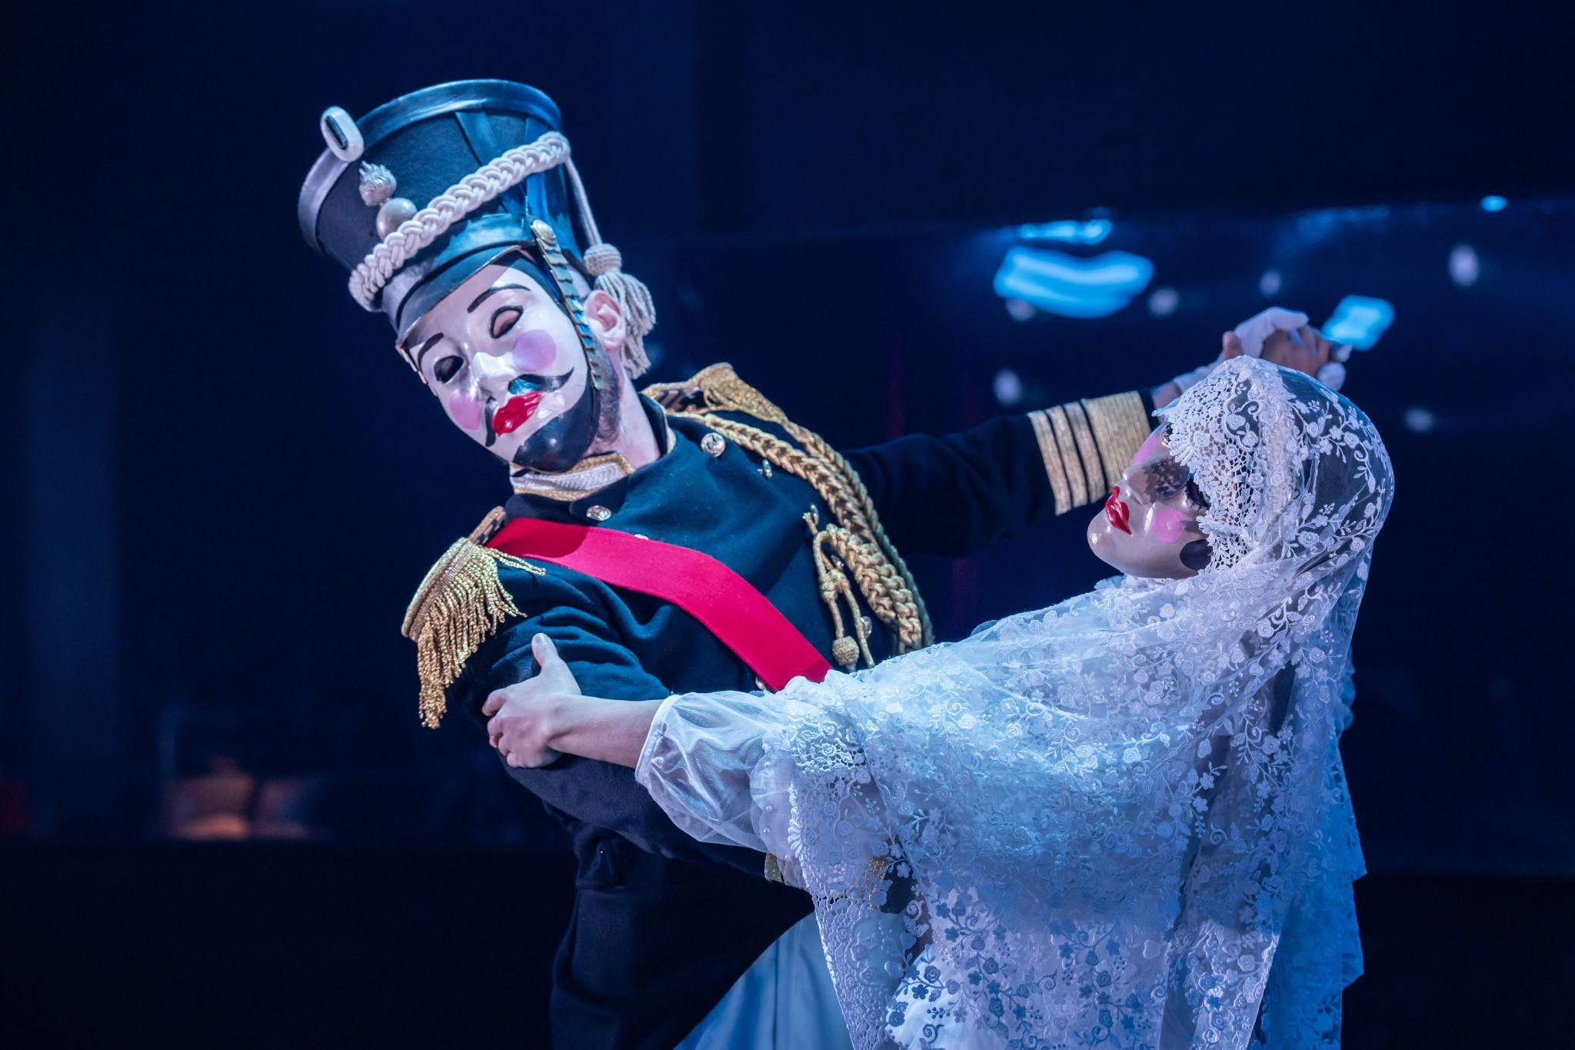

**Chapter 2**

# **4. The Private and Intimate Life of the House**

Synopsis

Prince Bolkonsky and his daughter, Princess Mary are at home. Prince Bolkonsky talks about how he is ageing and that he often forgets things. He talks about how they always have guests and that people often enjoy him. But, during the other 22 hours of the day when there are no guests, Prince Bolkonsky becomes demanding and controlling. Mary and Bolkonsky argue. Meanwhile Natasha is on her way to visit Andrey’s father and sister.. She is confident that they will like her. Back at the Bolkonskys, a young suitor arrives to ask for Mary's hand, but is shouted away by her father. Her father then invites a French lady to his house, to provoke his daughter. They dance together, explicitly and the french visitor leaves with his money. All of a sudden, Prince Bolkonsky becomes frightened and confused because he can’t find his glasses. Princess Mary feels guilty for this, and comforts her father.

Advisories

Incense is burned onstage for the duration of the song.

Drug use. It is not real.

Derogatory language.

Sexual references.

A character slides down a pole onstage and pretends to hurt himself. It is not real.

Sexually suggestive dancing.

Suggestion of violence.

References to dementia and illness.

*After the Old Prince says where's my glasses there are some flashing lights*

# **5. Natasha & Bolkonskys**

Synopsis

Natasha arrives at the Bolkonskys, Prince Bolkonsky is still distressed and Princess Mary attempts to hide him from Natasha. She notices him on the floor. Natasha tells us how from the first glance she does not like princess mary, she sees her as being too plain, affected, insolent and dry. Natasha and Princess Mary have a short standoff, they dislike each other a lot. As Prince Bolkonsky gets up, he itches his crotch, scaring Natasha. Prince Bolkonsky then dismisses Natasha. Natasha leaves knowing she hasn’t received Prince Bolkonskys blessing.

Advisories

Rude gestures.

*The fly buttons of Prince Bolkonsky’s pyjama bottoms may be undone but the actor is wearing something underneath so they will not fall down and he will not really show his body.*

# **6. No One Else**

Synopsis

Natasha worries about what she’s done, and wishes for Andrey to return. The Russian dolls show themselves to Natasha, to remind her that Andrey is still at war. Natasha’s bear falls from the ceiling, she goes to it for comfort. Natasha thinks back to the first time she heard Andreys voice, she tells us about the moon and how she blushed in the moonlight. She tells us how she can never love anyone else. She is comforted by thinking of his return.

Advisories

A big pink bear falls from the ceiling.

Confetti falls from the ceiling.

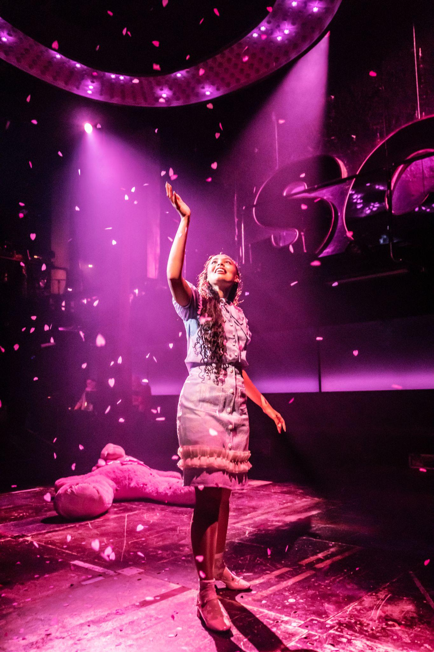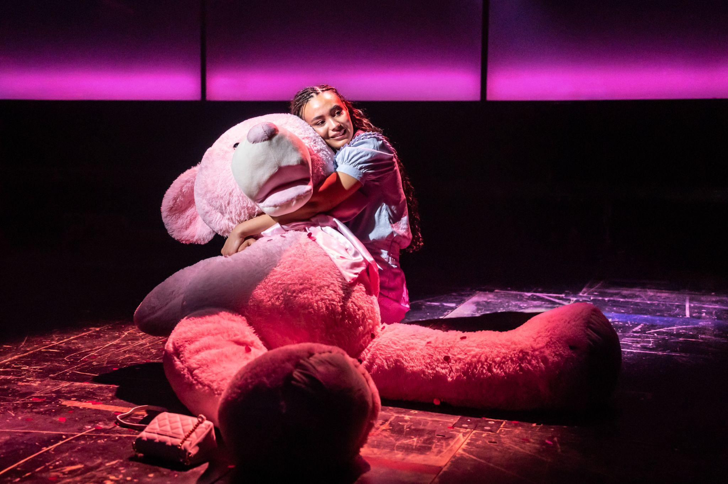

**PART II**

**Chapter 3**

# **7. The Opera**

Synopsis

Natasha, Sonya and Marya go to the Opera. Natasha is the talk of the town, because of her engagement with Andrey. Fedya Dolokhov arrives confidently and all the moscow ladies are mad about him. Quickly after this, Hélène Bezukhova arrives, Pierre’s wife, she is barely clothed and is the queen of society. Fedya and Hélène flirt in full view, whilst Pierre sits at home and reads. Everyone knows that Fedya and Hélène are ‘arm in arm’ (having an affair). Natasha spots Hélènes necklace full of pills and is drawn in by her sensual aura. Hélène becomes enchanted by Natasha. Marya very quickly intervenes and shares that Hélène is a woman she should stay far away from. The opera begins, and everyone watches through their binoculars from the box. Natasha is at first unimpressed, she doesn't understand it, and feels confused why everyone else is so taken by the show. But suddenly, as the opera continues, she begins to fall in love with the opera little by little.During the Opera’s interval there is a rush of cold air, Anatole Kuragin has arrived, Hélène’s brother, and he makes his way towards the front row to find his best friend, Dolokhov. Natasha notices that everytime she looks at him, he looks back at her. The Opera ends and everybody screams ‘Bravo’. Anatole makes his way towards Natasha’s box and they meet for the first time.

Advisories

A character holds a fake gun. It is not real.

Sexual references.

Bright white lights.

*Bright lights from the binoculars that the actors hold in front of their faces, hiding their eyes.*

Loud, high-pitched singing.

References to violence.

Sexually suggestive dancing.

Two characters dance with a fake knife. It is not real.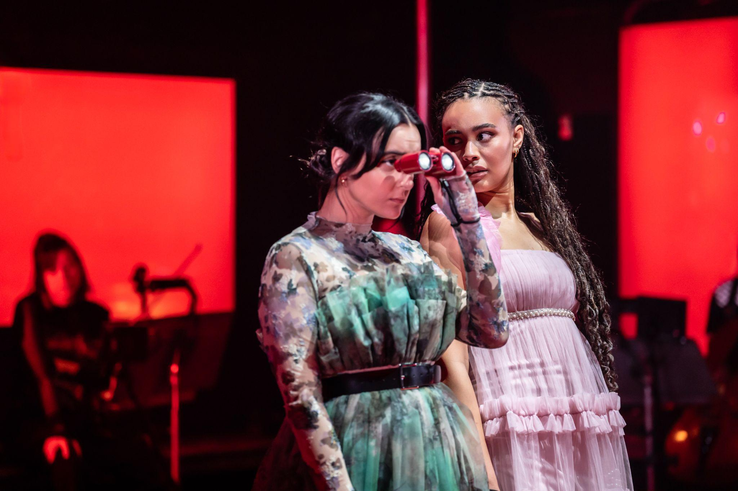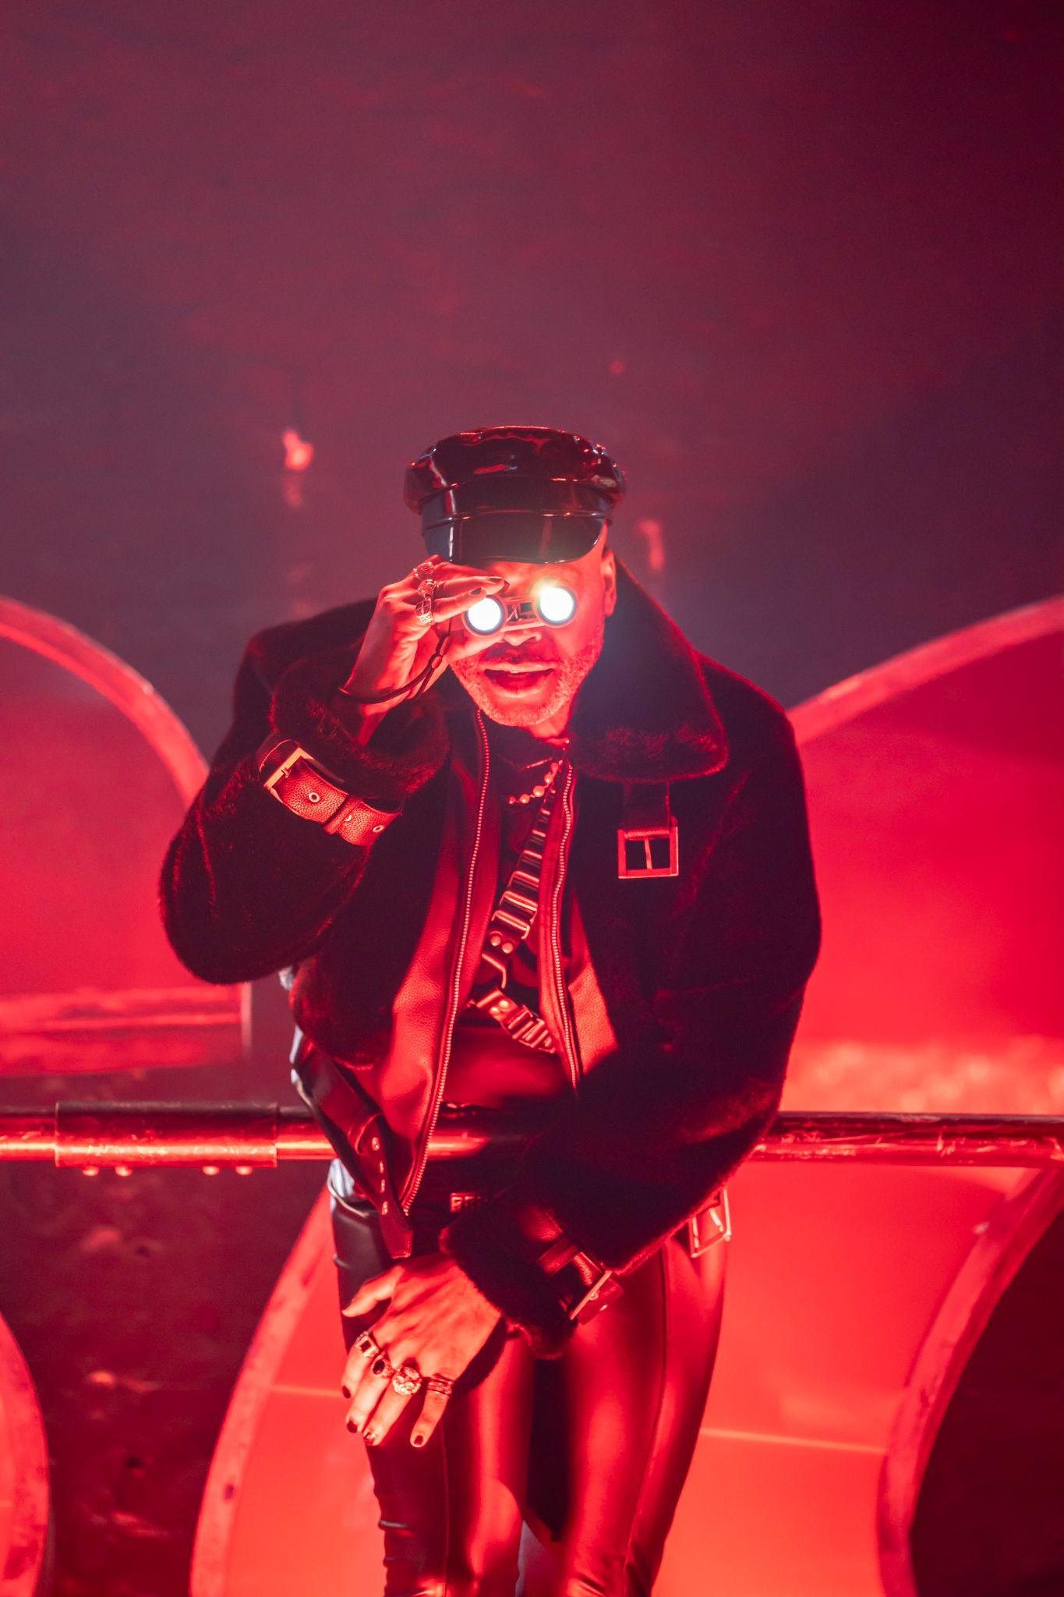

# **8. Natasha & Anatole**

Synopsis

Anatole and Natasha speak about the Opera. Natasha tells us about Anatole, how his smile is most naive, cheerful and good natured. Anatole invites Natasha to a costume tournament (The Ball) that he is having soon. Natasha is unsure, because she has noticed how much Anatole is flirting with her. She begins to fantasise that Anatole might seize her from behind and kiss her on the neck. There is a lot of tension between them. Anatole goes to hold Natasha's hand, and as they look into each other's eyes, she accepts his hand and they continue to watch the Opera as their hands touch.

Advisories

Loud, booming sounds.

Bright white lights.

Sexual references.

**PART III**

**Chapter 4**

# **9. The Duel**

Synopsis

After the Opera, Anatole visits Pierre, who is still at home reading. Anatole wants to go to the club but needs money so invites his brother in law Pierre to join him. Pierre, Dolokhov and Anatole arrive at the busy and loud club. Pierre tells us how his drinking is getting dangerous, and that he has been warned by the doctors to stop drinking so much vodka and wine. Dolokhov and Anatole taunt Pierre, and force him to drink even more. As they celebrate, Dolokhov tells us how Anatole is married. Anatole shares that it doesn’t matter, he tells us how he just loves women and enjoys the game of it all. Hélène arrives and notices her husband's intoxication, she tells him to keep drinking. She begins to flirt and kisses Dolokhov in front of Pierre, which angers him. Pierre challenges Dolokhov to a duel. The duel begins, and Pierre shoots Dolokhov in the shoulder. It is now Dolokhovs turn, and Dolokhov is known for his precision with a gun. However, Dolokhov misses and his friends take him away to the hospital for treatment. Pierre stands at the end of the duel as the winner but Hélène forces him to the ground in fury for suggesting a duel ‘you are a fool’. Anatole asks Hélène to go and ask Natasha to the ball for him; she agrees. Pierre is left all alone, drunk and tired.

Advisories

Bright, flashing, coloured lights.

Sudden changes in lighting and sound.

Loud, booming bass sounds to mimic a club.

*Some of the actors are swinging Poi which light up green, they swing them very fast but they do not throw or let go of them or hit anybody with them*

Shouting and depictions of chaos. It is not real.

Excessive alcohol consumption and drunkenness. These are not real.

References to alcoholism.

References to poor mental health.

Rude gestures and language.

Sexual references.

References to coercion.

Characters use fake guns. They are not real.

A character climbs up the pole onto the balcony. He is safe.

Two characters suspend from the ceiling, standing on the bar above the balcony. They use wrist straps for support and are completely safe.

One character holds the strap and is lowered back down to the stage. He is safe.

There are loud gunshot *sound effects*. *The guns do no really fire*

References to violence and depictions of violence. It is not real.

Allusions to suicide.

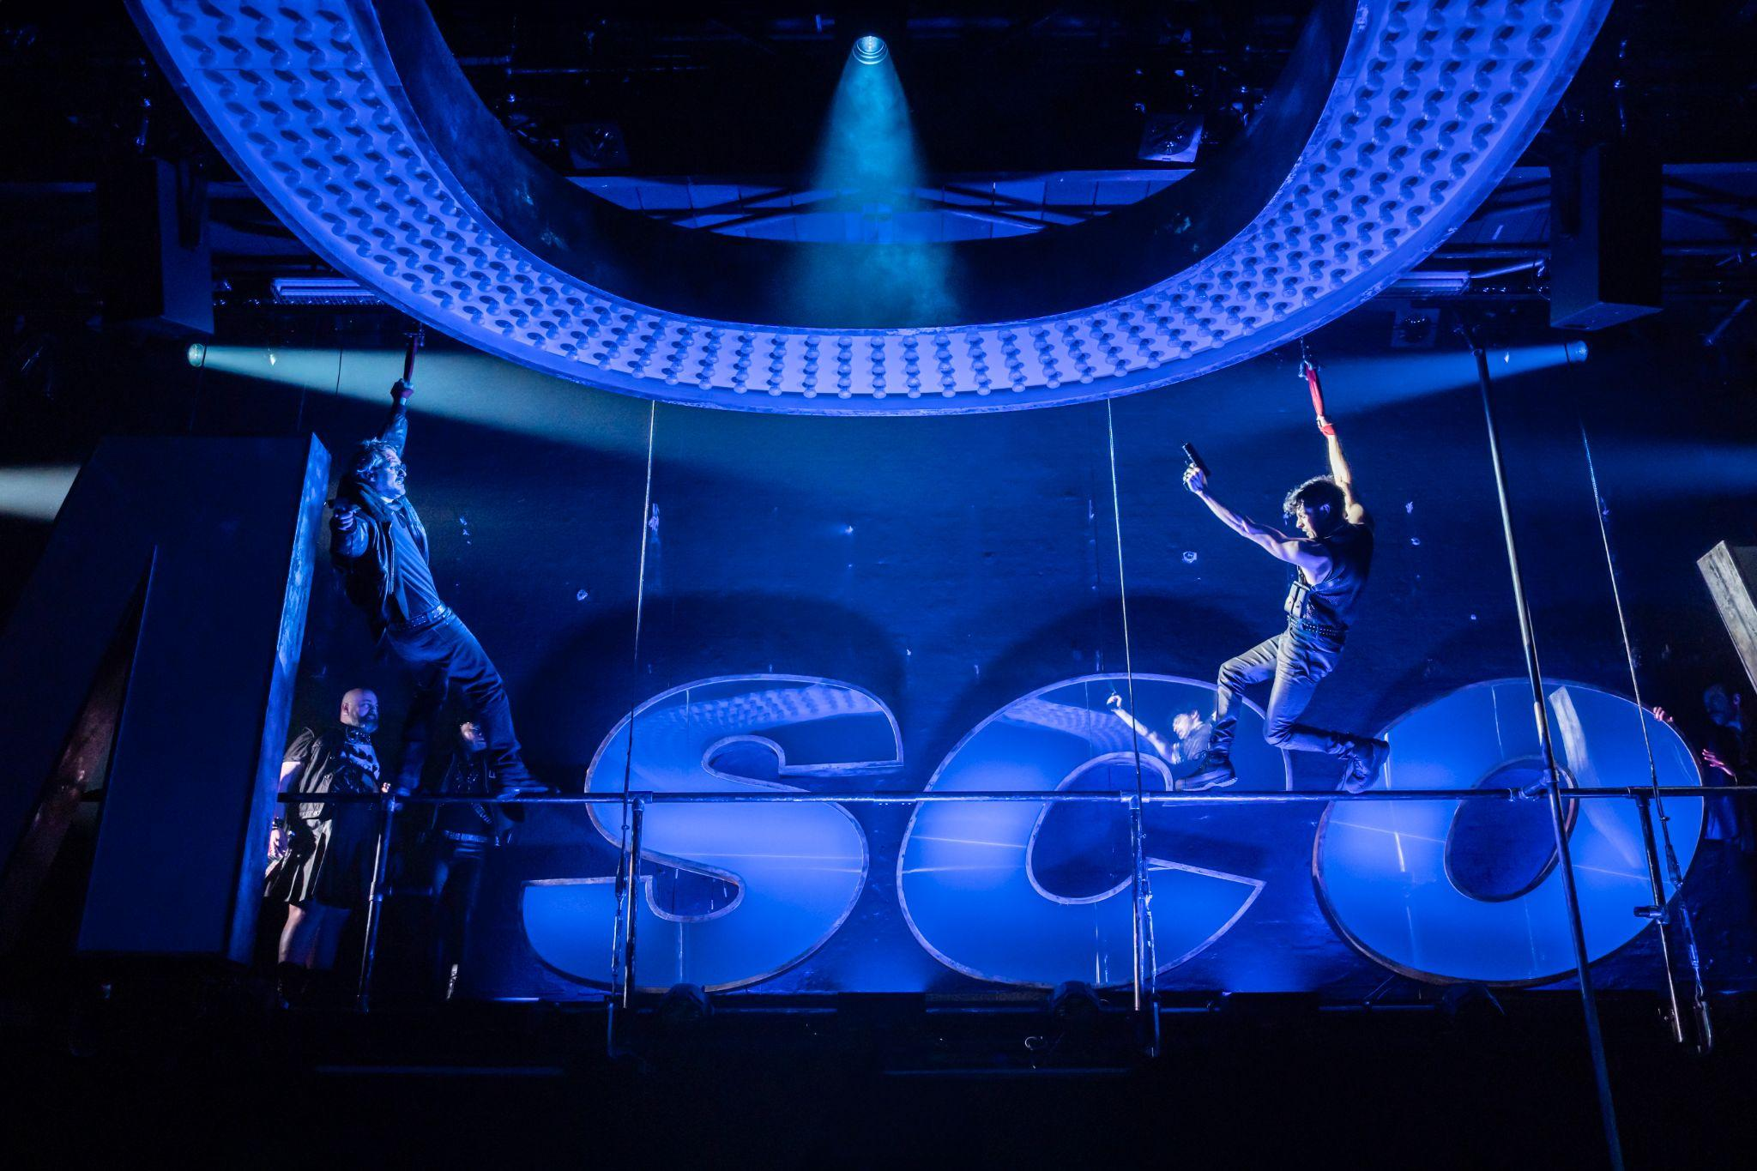

# **10. Dust and Ashes**

Synopsis

Pierre sees his reflection, and tells us about how he is being made into a fool. He feels as though he has done nothing with his life. Pierre pleads that he not die like this, without any life or love. Pierre wishes to wake up, the only issue is he doesn’t know how.

Advisories

References to and depictions of poor mental health.

References to alcoholism.

Alcohol consumption. It is not real.

References to mortality.

One character throws bottles onstage. They are made of plastic and won’t hit anyone.

One character retrieves a plastic bottle from beneath a seat on the front row.

**Chapter 5**

# **11. Sunday Morning**

Synopsis

Sonya and Natasha light a candle in the mirror. It’s said that if you look into the mirror holding a candle you can see your future. Natasha is conflicted about her evening with Anatole, and questions whether she has broken her faith with Andrey. She is afraid that if Andrey doesn’t return soon, something might happen to her. Natasha has told Marya about her awful time with Andrey’s father, Prince Bolkonsky. Marya promises to go and speak with him. Once Marya leaves, there is a knock at the door.

Advisories

A candle is lit and blown out onstage.

Alcohol consumption. It is not real.

References to mortality.

# **12. Charming**

Synopsis

Hélène visits Natasha. She attempts to seduce and charm her into attending Anatole's costume tournament (the ball) this evening. Hélène explains how Natasha’s fiancee would want her to have fun. She has bought Natasha some red lingerie. Natasha agrees to attend the ball.

Advisories

Sexual references.

Themes of coercion.

**Chapter 6**

# **13. The Ball**

Synopsis

Anatole is waiting at the door for Natasha’s arrival. Natasha arrives frightened, she is conflicted by her love for Andrey, and her new found feelings for Anatole. She has come to end things with Anatole. But Anatole charms her, and they begin to dance. Natasha tries to tell Anatole that she is betrothed to another, that this is wrong but Anatole doesn’t give up. He continues to push for her attention. The Russian dolls appear as Natasha is in conflict. Anatole kisses Natasha. She falls in love with Anatole, and Anatole begins to unzip her dress, and we see the red underwear that Hèléne had given her earlier today.

Advisories

Lit candles are used by the cast onstage.

The cast wear masks. They partially or completely cover their faces.

A character uses the pole onstage.

Sexual references.

References to coercion.

Depiction of mild threat.



**INTERVAL**

**PART IV**

**Chapter 7**

# **14. Letters**

Synopsis

Letters drop from the ceiling and the chorus share why writing letters is important for them. A microphone in the centre is used by the characters when they are writing a letter, to symbolise this act. Pierre writes a letter to Andrey, asking about the war, and updates him on his life. He has been studying and thinks that what he needs is to find and kill Napoleon. Natasha tries to write a letter to Andrey, but she doesn’t know what to write because of her feelings for Anatole and their kiss. Pierre and Natasha are both lost in their own ways. Mary writes to Natasha to try and make amends after the way her father, Prince Bolkonsky acted when Natasha visited their house. Natasha attempts to respond, but again, doesn’t know what to write. Mary now joins Pierre and Natasha as they all sing about not knowing what the future holds. Next, Anatole, with Dolokhov’s help, sends a love letter to Natasha (now referred to as Natalie). In the love letter, Anatole expresses that he “wants nothing more” than to love Natalie and run away with her - “steal you away in the dark”. Natasha basks in the attention and adoration and says she loves Anatole. Sonya finds the love letter that Anatole sent to Natasha.

Advisories

Letters fall from the ceiling onto the stage. They will not hurt anyone.

References to war and violence.

Allusions to alcoholism.

References to poor mental health.

Sexual references.

**Chapter 8**

# **15. Sonya & Natasha**

Synopsis

Sonya is in disbelief after reading the love letter that Anatole sent Natasha. Natasha realises Sonya knows about her secret relationship with Anatole and expresses relief that she can share her excitement with her friend. But Sonya has not received the news well. She doesn’t believe Natasha could love Anatole after only knowing him for three days and asks Natasha what she will do about Andrey. Has she refused him? Natasha reacts defensively. Her engagement to Andrey is irrelevant in comparison to her love for Anatole. She will do anything to love Anatole and be his, asking Sonya “why can’t you understand?”. Sonya can’t accept Natasha’s decision and threatens to tell others Natasha’s secret. The argument between the two friends escalates. Natasha responds with abandon; she doesn’t care about the consequences and tells Sonya that she hates her. This interaction prompts Natasha to finally respond to Princess Mary, telling her that she “can’t be Andrey’s wife”.

Advisories

Representation of conflict and anguish.

# **16. Sonya Alone**

Synopsis

Sonya is left alone, afraid of what might happen to her friend. As the days go by, Sonya realises that it is true that Natasha is planning to run away with Anatole. She questions what she should do, how can she help? Because of her immovable love for her best friend, she promises to stand in the dark for Natasha. She will do anything she can to protect her from Anatole.

Advisories

**Chapter 9**

# **17. Preparations**

Synopsis

Anatole, Hèléne and Dolokhov have heard about Sonya and Natasha’s argument, because of this they have made plans to abduct Natasha in the night. They await Balaga, the troika driver who will help steal Natasha away. Dolokhov is worried that this is a bad idea, and checks with Anatole about whether he is sure. He tells us how this is dangerous business and how he could go to jail for eloping and marrying another woman. Anatole stands up for the plan and wants to push forwards.

Advisories

Drug use. This is not real.

# **18. Balaga**

Synopsis

Balaga the troika driver arrives. Balaga is a famous troika driver, and he is known for driving for the high society. He often drives in the night, and is involved in organised crimes. Anatole and Dolokhov celebrate Balaga’s arrival.

Advisories

*Brightly coloured flashing lights*

The cast dance with feathers.

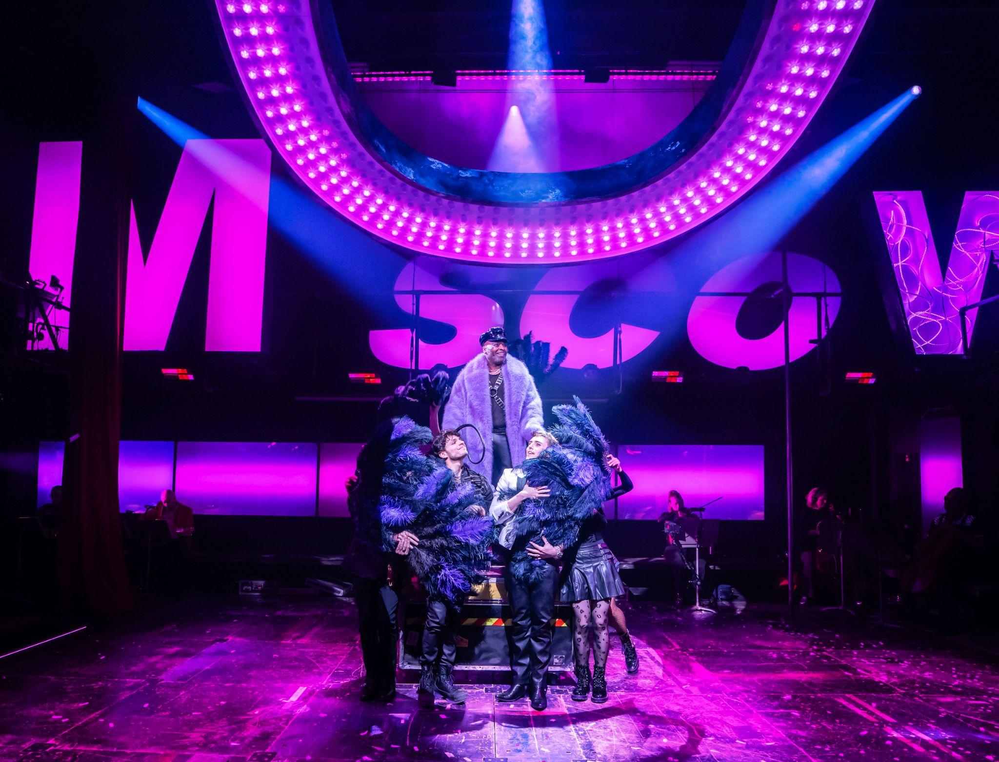

# **19. The Abduction**

Synopsis

Anatole goes to the club to say goodbye to all of his ‘moonlight lovers’. They have one last drink, to celebrate his elopement. Dolokhov realises they are missing the fur cloak, the last thing they need before the abduction. He tells us how he's heard stories that you must keep the woman warm, because they will be frightened and cold. They use Balaga’s fur coat. It’s time for the abduction, they arrive at the front gate. Natasha’s maid is there to let them inside, but just as Anatole is about to reach Natasha, Marya intercepts them with a gun. Sonya has told Marya about Natasha and Anatole. Marya scares Anatole away, and they all leave quickly. Sonya holds Natasha back from chasing after Anatole.

Advisories

*The actors will drink from shot glasses, they will also offer a glass to some members of the audience -it is not real alcohol*

*Balaga will sit on the knee of someone in the front row of the audience and flirt with them*

*When they talk about the abduction the actors wrap the fur coat around a member of the ensemble and lift her up. This is done safely and she is not hurt or frightened when it happens.*

*When they say “let’s get out of here” Balaga jumps back on the troika (flight case) there are flashing lights and strobe lighting which lasts for about 15 seconds*

*A shotgun is seen onstage and pointed at other actors but not fired.*

**PART V**

**Chapter 10**

# **20. In My House**

Synopsis

Marya shouts at Natasha, furious about how she has behaved. Natasha tells Marya how she has refused Prince Andrey. Marya is outraged by this, and tells us how Natasha has let down the family. Natasha cries in devastation, and Sonya attempts to calm her but Natasha cries out, and feels betrayed by her friend. Marya see’s Natasha’s irrational behaviour and decides she must do something about this. Sonya goes to get Natasha’s bear, and Natasha waits at the window for Anatole in the hope he will return for her again.

Advisories

Loud music and shouting

# **21. A Call to Pierre**

Synopsis

Marya seeks out Pierre for help. She tells him everything that has happened, between Natasha & Anatole. Pierre reveals to Marya that Anatole is in fact married. Mary is shocked by this, she tells Pierre that he must go and find Anatole and tell him to leave Moscow because if Natasha’s father finds out he will kill Anatole in a duel. Pierre agrees.

Advisories

Loud music and flashing lights

**Chapter 11**

# **22. Find Anatole**

Synopsis

Pierre searches for Anatole. Meanwhile Marya returns home to tell Natasha that Anatole is already married. Natasha can’t believe that this is true, she is heartbroken by this news. Anatole shows up at Pierre’s house. Hèléne attempts to protect her brother, but Pierre stands his ground and wishes to speak with Anatole alone.

Advisories

Loud music and shouting

# **23. Pierre & Anatole**

Synopsis

Pierre questions Anatole's intentions with Natasha, and becomes furious with Anatole's nonchalant attitude towards the situation. He grabs Anatole by the neck and almost punches him in the face, but stops himself. Pierre tells Anatole what he must do next, and insists that he must return Natasha’s letters and leave Moscow immediately. Meanwhile, Natasha is so devastated by Anatole’s betrayal that she takes some arsenic. Back at Pierres, Anatole withholds giving the letters over, until Pierre gives him money for his journey out of Moscow. The next day Anatole left for Petersburg.

Advisories

Depictions of self-harm

**Chapter 12**

# **24. Natasha Very Ill**

Synopsis

Sonya tells us that Natasha is ill. She poisoned herself with arsenic. In the middle of the night, Natasha woke Sonya up to tell her what she had done. The doctors came and saved her life. Andrey is set to return from the war, and they await his return with dread.

Advisories

# **25. Pierre & Andrey**

Synopsis

Andrey visits Pierre. It’s been a long time, and Andrey reminds us that there is a war going on out there. He asks Pierre whether what he has heard about Natasha is true. Pierre wonders whether his friend could forgive her. But Andrey can not, he hands Natasha's letters to Pierre and smiles similarly to how his father does, and says he can not forgive her for what she has done. Andrey tells Pierre that if they want to continue to be friends, then Pierre must never speak of Natasha again.

Advisories

**Chapter 13**

# **26. Pierre & Natasha**

Synopsis

Pierre goes to visit Natasha, she is still recovering. Natasha asks Pierre about Andrey, and asks whether he will forgive her. Pierre gives Natasha back her letters. Natasha begins to cry, as she knows it is all over between her and Andrey. She feels as though her life is ruined. Pierre tries to comfort her, but she says that she is not worth his kind words. Pierre tells Natasha that if he were not himself, he would ask Natasha for her love because she is worth it and she has her whole life ahead of her. This level of compassion and kindness makes Natasha cry further, but tears of gratitude and tenderness. She leaves the room smiling.

Advisories

*Natasha will look upset and may cry, this is the actor pretending, she is not really upset.*

# **27. The Great Comet of 1812**

Synopsis

Pierre is unsure of where to go next. He is taken aback by Natasha's tears, and the moment of connection he has just experienced. He experiences a moment of enlightenment as he witnessed the great comet of 1812. He has an uplifted soul and a newly melted heart.

Advisories

**GENERAL SHOW NOTES AND ADVISORIES**

The Music:

The characters rarely speak in this show. Almost everything is set to music and sung by the cast. Some of the music sounds like songs you might expect to hear in a musical, like ballads and show tunes. Sometimes the singing is more like a conversation, and sounds more like speech, even though it is still sung. This is called recitative.

There are lots of different styles of music in the show and sometimes the switch between styles happens very quickly. There is electronic music and electronic sounds as well as more typical musical theatre show tunes, operatic music, and club music with heavy bass sounds.

Near the end, in 26. Pierre & Natasha, Pierre speaks a few lines of text, rather than singing them.

The Setting:

The musical is based on a 70 page section of the Russian novel ‘War and Peace’ by Leo Tolstoy, originally published in 1867. The setting of the musical is the same as in the book: 19th century Moscow. This production brings the story into a more contemporary setting, whilst nodding to the original time and space.

General Advisories:

A large circular set piece with coloured lights sits suspended above the stage. It moves up and down, tilts, and changes colours. Sometimes the actors stand in the centre of the circle when it is low down. Sometimes actors stand on top of the circle when it is on the floor. It is safe for everyone.

